COMPUTING AND IT IN THE WORKPLACE
GROUP ASSIGNMENT
INTAKE CODE- UC1F1809CS/CS(DA)/IS

GOOGLE Inc.

Members:

Ahmed Mohammed Ali Qaid | TP053094
Zhang Ziteng | TP052096
Leong Soong Jun | TP050994
Vaibhav Arora | TP052691
Abdullah Feroz Ansari | TP052686

Marking Criteria
The assignment will contribute 50% towards the in-course assessment, as mentioned on the Student Assessment & Information Sheet (SAIS). The document must contain the marking grid (work breakdown structure) as per the sample shown below, which should be printed next to the cover page. Any document that does not contain the marking grid will forfeit the entire 10% marks and will be allocated 0 marks for this section!

Distinction A+, A
Demonstrated comprehensive research with detailed evidence. High level of analysis performed, exceptional and thorough knowledge and understanding displayed with regard to application. This includes analysis and evaluation of facts followed by results of evaluation. Documentation presented in a professional manner, following proper sequencing and flow. Displayed evidence of critical appraisal. Correctly listing in-text citations and references.

Credit B+, B
Adequate research conducted with fair detail of evidence presented. Moderate level of understanding, analysis and knowledge displayed. Some level of relevance included in terms of application. Moderate level of analysis and evaluation of facts followed by results comparison. Good level of documentation presented. Some level of reflection was evident in the documentation. Moderate level of listing citation and references.

Pass C+, C, C-
Low level research conducted. Some evidence of research displayed. Basic level of understanding and knowledge analysis displayed. Satisfactory level of documentation. No evaluation and analysis of facts, no results comparison performed Satisfactory or low level of reflection displayed. Low level of listing citation and references.

Performance Criteria
Group Component (60%)
Fully | Partially | Not | Performance Criteria
Distinction (51 – 60 marks)
All credit criteria fully met
Produced professional group report with in-depth research
Group analysis has clear evidence of original ideas
Excellent quality documentation that adheres to Harvard Referencing
Credit (31 – 50 marks)
All pass criteria fully met
Citing and referencing are accurate
Conforms completely to Report Guidelines
Group work has Introduction, Benefits and Compare and Contrast, and Conclusion
Adequate research undertaken with understanding, analysis and critical thinking
Group Evaluation and Conclusion shows some thought
Satisfactory documentation with minimal grammatical mistakes and spelling errors
Pass (0 – 30 marks)
Table of Contents
Group discussion on all topics attempted
Introduction and Conclusion attempted
Citation and References have been attempted
Individual Component (40%)
Name  Grade |  |  | Student 1 | Student 2 | Student 3 | Student 4 | Student 5
All topics addressed  (10 marks per criteria below) |  |  | Fully Partially Not | Fully Partially Not | Fully Partially Not | Fully Partially Not | Fully Partially Not
Individual Analysis (understanding) |  |  | Fully Partially Not | Fully Partially Not | Fully Partially Not | Fully Partially Not | Fully Partially Not
Original Ideas and Critical Thinking |  |  | Fully Partially Not | Fully Partially Not | Fully Partially Not | Fully Partially Not | Fully Partially Not
Research and References |  |  | Fully Partially Not | Fully Partially Not | Fully Partially Not | Fully Partially Not | Fully Partially Not
Presentation |  |  | Fully Partially Not | Fully Partially Not | Fully Partially Not | Fully Partially Not | Fully Partially Not
Additional Comments

Abstract

This assignment is about the various aspects of a company, which has made the research process simpler, helps in daily house chores (just google what you don’t know!) and made our life simpler in many other ways. The company is GOOGLE. The contents shall explain the many features of such a company and elaborate upon what needs to be known by the reader. The information mentioned in the thesis is based on facts and personal opinion. The topics that are to be discussed are Green Computing, Health issues, Video Conferencing, Security and Internet. The green computing part explains how google is using different renewal energy sources. It has all data centres running on renewal energy which has not only saved money but also preserve mother nature. We have compared our energy consumption with our competitor Apple. The carpel tunnel syndrome portion explains how long working on computers has impact on the human body and if this is ignored it may eventually develop into a huge pain and be irreversible damage. Today technology has made everything available at our fingertips without moving to any location. Video conferencing, this has not only made face to face communication between users possible in any corner of earth but has also saved tons of company’s annual expense on traveling of employees and organizing meetings. Today, whatever problem we have we ask Google for solutions. In fact, it has become that Google knows us better than our own parents. So, it is important for this data to be secured and confidential. We explore how google as a company has taken steps to keep the data protected from cyber security threats and also different physical security measures followed and taken in premises. The last component can’t be forgotten that is internet because google is recognized for its search engine and web browser Chrome. And we have compared it with another browser in the industry. All these components are explained in detail in the following part.

Table of content-heading format

Marking Criteria 3
Performance Criteria 4
Abstract 7
Acknowledgement 9
INTRODUCTION 10
REASON BEHIND CHOOSING GOOGLE 11
Green Computing 12
Introduction 12
Google versus Apple 12
Two energies 13
Three methods to promote green computing 14
Carpal Tunnel Syndrome 15
Introduction 15
Explanation of CTS 15
CTS Healing Methods 16
Methods on proper workplace ergonomics 17
Video Conference 17
What is video conferencing ? 17
Cost for video conferencing 19
Comparison 20
Security 22
Trojan Horse 22
Preventive Measures Against Malwares 23
Biometrics Recommendations 24
INTERNET 26
NETIQUETTE: 26
WEBSITE: 27
WEB BROWSER: 29
COMPARISON TABLE 30
Compare & Contrast 32
Conclusion 34
Reference 35
Weekly Task report 44
Work Breakdown Structure (WBS) 45

Acknowledgement

To begin with, we would like to thank our teacher Ms. Hairul Aysa Binti Abdul Halim Sithiq who helped and guided us in bringing this assignment. This project has alleviated our knowledge by conducting research about various aspects of computing and technology in workplace.
I would like to thank my group members Ahmed Mohammed Ali Qaid, Leong Soong Jun, Zhang Ziteng and Vaibhav Arora for their sincere collaboration and cooperation throughout the project.
Secondly, we would like to thank our parents who were a great source of motivation and help in accomplishing the assignment

INTRODUCTION

Google is an American multinational IT company that mainly majors in internet-based services and technology in general. It was founded in 1998 with an equity capital of $100k. The history of Google begins as a research project called “Backrub” conducted by the co-founders Larry Page and Sergey Brin while they were attending Stanford University as PhD candidates. As Page and Brin started Google in a garage, Google’s first server was made from Lego. Google was first created as an online search engine; however, it now offers more than 50 internet services and products (i.e. Mobile phones after the acquisition of Motorola Mobility by Google in 2012). Nowadays, Google is a subsidiary of the holding company Alphabet and its main headquarter is located in California, United States. Google has more than 70 offices in 50 countries around the world. According to CNN, Google has a net worth of $762 Billion, moreover, it holds more than 88 thousand employees as of 2017 according to Statista.
Google’s diversity in the technological field makes it one of the top influential high-tech companies. Google focuses on Cloud Computing, online advertising technologies, software applications, hardware devices and for sure its popular search engine! Google’s core of success “Google search engine” has 92.74% of the search engine market worldwide (Statcounter, October 2018) making it at a crucial position in the internet.
In this research, an area of computing and information technology at Google is to be investigated. Since Google has been rapidly developing and expanding in various tech fields, there are five different sections presented in this research. First, it will describe the positive effects of green computing in Google and how to reduce its carbon footprint. Secondly, it will discuss the ways towards prevention of Carpel Tunnel Syndrome as well as the ways to heal against it. Then, it will also discuss the qualities needed implement a Video Conference platform and its costs. Last but not least, the risks of security breaches and their consequences and how to avoid them. Finally, the possibilities and the strategies of Google and its plans towards expanding its presence overseas via the internet. To sum up, these five sections can be assigned as the whole field of computing in an organization or CITW (Computing and Information Technology at the Workplace).

REASON BEHIND CHOOSING GOOGLE

Google.com is one of the most successful search engine websites with around 5.5 Billion searches per day (Sullivan, 2016). In June 2018, Google was estimated to have 63.2% of market share amongst the major search engine websites and also it has over 247 million unique visitors in the U.S. (Gordon, 2018)
That’s why, it was termed as the leader amongst the most visited multi-platform website in the United States.
Every aspect of our assignment can be implemented in Google i.e. Green Computing, Carpal Tunnel Syndrome, Video Conferencing, Security and Internet.
In Green Computing, the researcher can talk about how Google is changing the way they are using electricity by using the renewable energy and by disposing the old computers in a proper manner in order to protect the environment and to make it eco-friendly.
In Carpal Tunnel Syndrome, the researcher can talk about how this syndrome is affecting the employees of google, and how the google is using proper equipment and techniques to protect their employees from this syndrome.
Google is a big company, the managers frequently arrange meetings, talks and discussions with the clients, employees and with shareholders as well. So, the researcher can talk about how the company is saving time as well as money by using video conferencing feature efficiently.
Since more than a billion people rely on google with their information, the researcher can talk about how the google is securing their information as well as securing their own data.
Lastly, Google has its own reputable and fast browser, this makes it easier for the researcher to make comparison between google chrome and other browsers.

Green Computing

Introduction
In this global technological era, Google has more than just the world-wide searching engine on the world, and it has focused on the development and usage of new energies, green computing, and renewable energies. Google has 15 data centers around the world that consume a large amount of power which emitted Carbon Dioxide emissions to the Earth. After several years, Google started to apply renewable energy. In 2017, Google announced that the annual purchase of renewable energy output was eventually equal to the annual total electricity consumption. In a nutshell, Google has been leading the world in the use of renewable energy. (Wheeland, 2007)

Google versus Apple
Google and Apple are known as globally large-scale integrated technology companies. These companies have committed a lot of Carbon Dioxide to nature, get the number of emissions is uncountable.
Google
Firstly, Google had launched BLACKLE, which is an all-black background search webpage. It is designed to reduce energy consumption through a dark background. It is a computer monitor that consumes less energy. Secondly, Deep Mind is a subsidiary of Google that focuses on artificial intelligence. Two years ago, they successfully reduced the energy used for data cooling by 40% through artificial intelligence. In 2017, Google has officially hit its 100% renewable energy objective. (INVICTUS, 2018)
Apple
Besides, Apple did more visible to customers. For instance, Apple tried to study on Maximizing Performance Batteries. Apple introduced energy-saving settings on the mac system. They developed a power-saving mode On the iPhone. Moreover, Apple has contracted the First Solar to support its company with California Flats (a solar energy farm).

Two energies
Solar Energy
Solar energy technology generates heat by absorbing light radiation from the sun. It is one of the renewable energy sources currently being developed by humankind. The source of solar energy seems to be inexhaustible from the extended period, billions of years. Not only that, its environmental pollution to the earth is minimal. Solar technology has matured globally. In such an environment, the cost of solar energy on research and development is getting lower and lower, and the application range will be more extensive. That is why most companies are more interested in the development and utilization of solar energy in so many renewable energy sources nowadays. (MCGRATH, 2011) (INVICTUS, 2018)
In 2015, Google started a plan for solar energy which is called “Project Sunroof.” Google's engineer Carl Elkin developed the program in his spare time at Boston. People can calculate the energy they can save after installing solar panels on the roof through Google Maps and related data around their home. They can find out if their home is suitable to install solar panels and calculate the size of the solar panels.
Navigation has become a significant tool for people to drive. Drivers often have trouble with navigation when they drive. For some drivers, they may prefer to buy a particular mobile phone that only uses for navigation. There are many car companies in the study of the solar car. It is foreseeable that in the next 10-20 years, solar cars are likely to be promoted and popularized. Google can combine navigation and solar energy to develop a solar navigation tool for most model of cars. It will not only help to increase the number of existing users if Google developed the solar Google Maps tool. In the future, this technology will also combine new technologies such as solar cars and automated smart cars. In this well-developed era, it is an advanced technology that is hard to replace in the future.
Wind Energy
Wind energy is the energy produced by the flow of air. It is fundamentally a form of conversion of solar energy, which is caused by uneven heat on the surface of the earth. Human research and application of wind energy technology are more mature than solar energy. It is widely distributed, low cost, and capable of generating large amounts of energy with certain conditions.
Google's need for energy is mainly electricity. Through the Project Sunroof program mentioned above, Google can upgrade Google Maps on existing technologies. By determining the sun's coverage on the Earth surface, Google Maps can estimate the annual average wind power of the winds in each region. Thus, people can determine the area which is more suitable for wind power by Google Maps. People can establish a town, district, or their own home as the center of a combination of solar and wind power generation equipment with the help of Google Maps. Free electricity use will no longer be a dream in the future. What it will undoubtedly help to society is enormous.

Three methods to promote green computing
Use virtual technology to consolidate servers
Google is the largest worldwide research company. Citizens use the Google search engine as their needs every day. Energy consumption and carbon emissions are difficult to estimate. Therefore, Google can reduce energy consumption by reducing the number of physical servers. Google can build as many virtual servers as possible. Most servers are underutilized when they are used, so virtual servers instead of physical servers can reduce a lot of carbon emissions. (Shinder, 2008)
Recycle systems and supplies
The old systems and supplies can be reused, repurposed, and recycled. Reduce the load on already exhausted landfills and to circumvent sending dangerous materials to those landfills (where they can leach into the environment and cause harm). The organization outside the company can also reuse them. For instance, Google can donate old computers and other devices to public-service organizations.
Optimize data center design (AI)
Data centers are significant users of energy, and refrigeration the equipment is a big issue. Google has shown that DeepMind AI has reduced the cost of cooling its data center by 40% since 2016. DeepMind AI's main role in this module is to give the best advises to the system managers, which is about when to charge the system, and how to keep the system at the right temperature to reduce carbon dioxide emissions. It can be predicted that with the development and upgrading of technology, DeepMind AI will become more efficient in the future.

Carpal Tunnel Syndrome

Introduction

Google is the top-ranked well-known company and very concerned about his employees. Employees with long-term using computer keyboard and mouse in Google may face certain diseases. Basically, a co-worker in Google often use computer devices, therefore, it is difficult for computer users to avoid one of the diseases, named Carpal Tunnel Syndrome. This topic spread over countries to countries and companies to companies. Hence, Google had to encounter this problem to ensure their employees’ health in good condition.

Explanation of CTS

The carpal tunnel is a narrow passageway in the wrist. It is surrounded by the bones of the wrist and the transverse carpal ligament. The median nerve runs through the carpal tunnel and sends feeling to the fingers and hands. Many tendons pass through carpal tunnel therefore if swelling takes place, the large median nerve can easily be compressed, causing carpal tunnel syndrome. Flexor tendons run through the carpal tunnel into the hand and covered by a smooth membrane called the tenosynovium to allow hand movement. The present of thickening or swelling from inflamed tendons can reduce the space inside the carpal tunnel. Hence, once is neglected and inhospitality, the median nerve will squash against the transverse carpal ligament until the nerve cannot function properly. In this case, the results are numbness and pain yet able to affect one or both hands. The muscles of the thumb are serviced by the median nerve. A person with advanced carpal tunnel syndrome may find themselves cannot properly move their thumb and difficult to grasp objects.
(Nordqvist, 2018) (Claussen, 2011) (Charles D. Jennings, 2016)

CTS Healing Methods

Non-surgical treatment for Carpal Tunnel Syndrome
Firstly, the pain and stiffness may be slight on the patient. Hence, the pain will increase until their hand hurts all the time. The patients had to suffer permanent damage if the cause is not addressed.
Non-surgical treatments can include:
- Plenty of rest for the affected hand
- Physiotherapy
- Wearing splints on the affected wrist and hand at night
- Diuretic medications to reduce your body’s retention of fluid by increasing the amount of urine passed
- An injection of local anaesthetic and a corticosteroid medication into the affected area to reduce the swelling.

Surgery for Carpal Tunnel Syndrome

Open Surgery

Surgery is one of the treatment options for carpal tunnel syndrome. The surgeon makes an incision less than 5 cm long in your palm, and perhaps into the wrist to expose the transverse carpal ligament. The surgeon then cuts the ligament to reduce pressure on the underlying median nerve. The incision in the palm is sutured close to each other. The body’s healing process will join the severed ends of the transverse carpal ligament and resulting scar tissue should not press so hard on the underlying nerve. The pain and numbness might improve immediately or over time.
(Staff, 2017) (Bethesda, 2018)

Methods on proper workplace ergonomics

Ergonomic Chair
Google can provide an ergonomic chair to its employees. According to science, sitting will add stress to the structure of spines. A well-designed ergonomic chair allowed users to balance their sitting position. However, Google’s employees able to reduce the stress on the lumbar area with the support of the ergonomic chair. Thus, ergonomics chair can help to evoke good posture.

Ergonomic Mouse Pad
Google can prepare ergonomics mouse pad in the workplace. A mouse pad can help to minimize the pain that caused by carpal tunnel and maintain the wrist in a natural position. Thus, it facilities more efficient navigation and prevents vibration. With the help of ergonomics mouse pad, employee able to perform their work in the right position.
(Grosteffon, 2012)
Ergonomics Mouse
Ergonomics mouse is introduced to reduce the risk of the user’s health of the wrist. Ergonomics mouse is designed in the right shape and size of the user’s hand. In addition, it eases the tendon and muscle fatigue. Thus, ergonomics mouse helps to reduce the tension and use least effort to control it. Moreover, ergonomics mouse does not require the user to twist and move their forearm.
(Zych, 2013) (Solution, 2017)

Video Conference

What is video conferencing ?
It’s a technology which helps users located at different corners of the earth to communicate to each other face to face. It is better than olden times telephonic interviews and email, which earlier didn’t allow users to facially express themselves. This technology has facilitated a variety of users. (Janice, 2017)

Video conferencing can be conducted by the use of web cameras to view the parties involved, microphone to speak and speaker to hear them, nowadays all of these components are available built-in laptop, phones, tablet, and desktop computers. And a good internet connection to avoid any disruption. Businesses use special rooms for conferencing that are equipped with HD cameras and displays.

Typically, a software-based platform is utilized to transmit the communication over the Internet Protocol, in other words, a VoIP service; Voice over Internet Protocol, but today there are many webhosts available online that sanction users to hold professional video conferences utilizing their secure website. Applications like Apple’s Facetime, Google’s Hangout and Microsoft’s Skype have made it possible for people to use video conference technology on any device around the globe. . (Rouse, 2016)
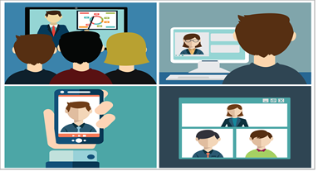
Video conferencing has helped businesses to communicate with different companies and individuals to express their ideas, negotiate deals, hold meetings, employees can collaborate and engage, help teams globally work together(virtual meeting room) and interview candidates for jobs. All of this is done on the workstation without moving to any location!
Video conferencing has benefited the company in many ways over the years here are few listed :
- Cost saving – The employees don’t have to travel from one place to another all the work is done on the desk thereby the travel ticket of the employee, hotel expenses, transport charges, food expenses and many other recurring expenses are saved.
- Increased productivity – Earlier the manger and few subordinates travelled for a meeting abroad this would make that department and sometimes the whole company in-efficient for that duration, since there was no one to monitor the activities in organization.
- A MNC which has its branches all over the globe, their managers now can be in touch with each other on a regular basis.
- Stronger relationship – The mangers can have meetings, discussions and frequent talk with the clients as well as with other employees. The stakeholders of the company around the globe can attend meetings.
- Reduce Carbon Footprint – Users can attend the meetings at their workstation without moving to any location, thereby less travelling so only few cars will be on the road. The carbon emitted in the environment will be reduced. (IVCI, 2017)

Cost for video conferencing
Today there are many video conferencing application out there, its difficult to select the best. All of these applications share all most the same features and they are available at a very reasonable price.
This technology has changed “how business do business” (Lachapelle, 2017)
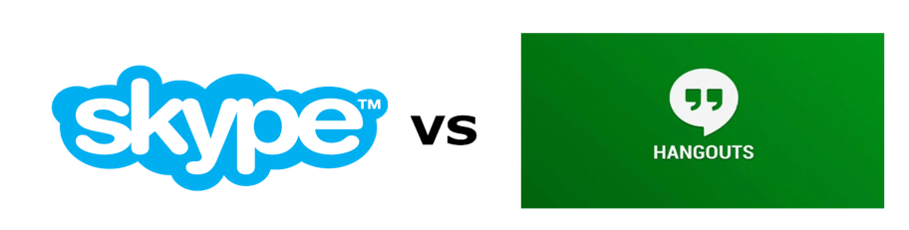
Well I have taken two products which have big name in the industry.
Google Hangout is a product by Google for video conference, accessible for all the users for free of cost. For business users out there, Google has specially developed for them Google Hangouts Meet. Google hangouts meets can be found in Google’s "G Suite” formerly known as Google Apps for Work which pools all of the well-known productivity and collaboration tools by Google and packs all of them in an all-in-one suite. (Guay, 2018)

Skype is a product developed by Microsoft for Video Conference.
The regular Skype can accommodate only 25 users but Skype for business has wide range of capabilities, it can accommodate upto 250 people and it is tightly integrated within Microsoft office 365 corporate packages and enterprise plans which makes it easy for user to share files and work on a common platform. On subscription of Microsoft Office 365 it not only provides access to Skype for Business but also a range of other Microsoft products. (Rashid, 2017)

Comparison :

Criteria | Google Hangouts Meet | Skype for business
Price | $5.00 per month per user | $5.00 per month per user
Business Sizes | Small Medium Large | Small Medium Large
Available on platforms | All | All
Instant chat | 100 people | 500 people
Video call | 50 people | 250 people
Cloud Storage | 30GB | 1 TB
Screen sharing :  This helps the user to share reports and make decision effectively | Yes | Yes
HD Quality video | Yes | Yes
Real time Document and File sharing | Possible up to only a limit | No limit
SMS | No | Yes , paid option
Landline/ Mobile calling | Yes, price depends on country | Yes, Monthly charge any country
Connected with calendar;  this helps to notify for the upcoming meetings and join them directly | Yes | Yes
Enterprise Level Security | Yes | Yes
Offline access to the documents | Yes | No
Third party integration | To be released in 2019 | Not yet annonced
(Guay, 2017) (Anon, 2018) (Jones, 2018)

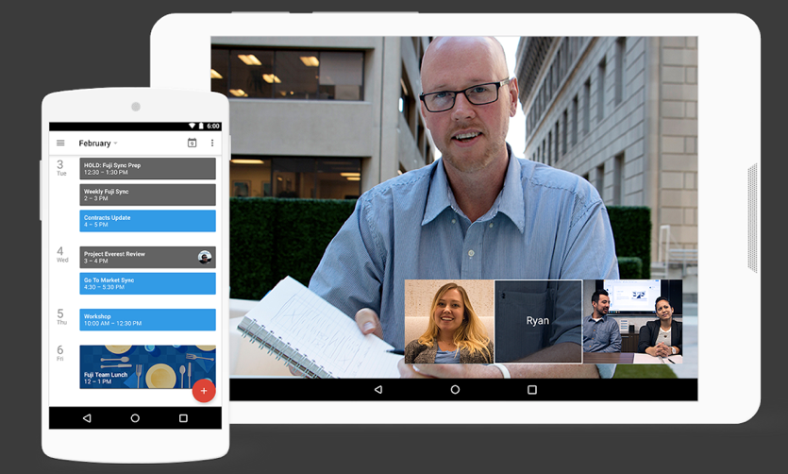
Figure 1: Screenshot of a video call on Google Hangouts Meet App on a Tablet. And schedule of upcoming meeting on Google Hangouts Meet App on a smartphone

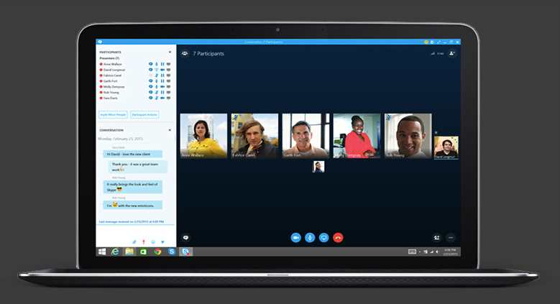
Figure 2 : Video call between individuals on Skype conducted on a laptop.

Figure 3: You just need internet to make a video call with your colleagues located across the world on any device.

Security

Trojan Horse

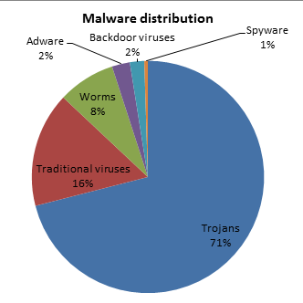
Google is an extremely aware company in case of security since more than a billion people use Google and rely on it with their information, that even iCloud runs on Google’s servers! However, the company’s frame-ware may get breached by specific means like Trojan Horses.
Figure 1 Shows Trojan Distribution Among Other Malware
A Trojan Horse or what people just call “Trojan” is a program that appears to be useful and harmless while it is in fact malicious. The term “Trojan Horse” comes from a Greek mythology from the Trojan war. In computing, this term was first used in 1974 by U.S. Air Force.
Unlike viruses and worms, Trojans can neither reproduce nor propagate without the user’s interactions. However, Social Engineering tactics are used to trick and convince the user into downloading and installing legitimate-looking software. Trojans are typically hidden in ads, E-mails, Free Programs or documents that they won’t look executable.
It would be intimidating to know what Trojan can do in your machine. Ironically, the user is the one who starts all this fuss. Trojan is classified into different groups with different abilities. For instance, “Backdoor” can provide full remote control to the attacker, “Trojan-spy” provides keylogging in which the user’s keyboard strokes are tracked to obtain data like passwords; and other types of trojan with different purposes. Furthermore, Trojans can be used to inject viruses and worms into the computer, activate the computer’s camera and microphone, or encrypt the user’s data in exchange for ransom.
Google has experienced some security breaches by trojans. One of them was Operation Aurora in 2009 in a bid of stealing the company’s intellectual property. “Employees received E-mails Monday and Tuesday masquerading as communications from within the company that included Trojan-laden attachments or Web links” said Gipson Hoffman & Pancione (Mills, 2010). According to CNET, attackers used multiple tailor-made Trojan. Some of the attacks had the attack code set to download “Hydraq-Trojan” into the victim computer.
Not only Aurora but also “Mydoom” (2004) hit Google hard with DDoS attacks. When Mydoom is executed, it moves to Windows system folder as “Taskmon.exe” (legitimate file) and creates the file “Shimgapi.dll” in the system folder. This file is a backdoor trojan.
Besides these cyber-attacks, Google Play Store has purged more than 20 trojan horse apps for spying on users by monitoring their Emails, voice, calls and Camera on the infected devices.
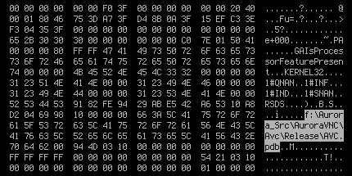
Figure 2 Shows the Compiled Binaries for Operation Aurora

Preventive Measures Against Malwares
There are some approaches to prevent malwares from entering your machine. In my perspective, the only way to guarantee a 100% security in your computer is by totally disconnecting it from the internet and make sure to never insert a removable device into your machine. However, there will be no purpose to use our computers without internet.
Anti-Malware is almost a must-have software on every computer. I would consider it the first preventive measure against malwares. However, it is your responsibility to choose a suitable Anti-Malware and make sure it performs well on your machine. Basically, many Anti-Malware programs scan for malwares using a database of known definitions called signatures. There are also other ways called: Heuristics, Sandboxing, and Removal. Additionally, it is recommended that you keep your Anti-Malware’s database up to date, as well as your operating system.
The second preventive measure is Complete Awareness while surfing the internet. Although, it is not a technical measure, it is substantial to consider since -as previously mentioned- the only way to share trojan is by using Social Engineering tactics. So, don’t run any untrustworthy programs even if you feel like you really need them, because you will only get negative consequences from it. Moreover, never download any unknown E-mails’ attachments or click on unknown links, although an email might look friendly as if a friend of yours sent it, or it could be formal and mentions a thing you are interested in. You can differentiate the spurious emails using common sense. On top of that, you can make it easier to spot malwares by showing hidden file extensions; such as: “. PDF.EXE”.
Our devices connect to the internet daily via Wi-Fi. Thus, we must make sure that our network is secured. Never connect to an open non-encrypted Wi-Fi connection. Moreover, the connection should be secured using WPA or WPA2 encryption as WEP is no longer secure enough since it can be bypassed in minutes. In case you run a file you suspect is ransomware, immediately disconnect from the network as you may have a chance to cut the communication with the C&C server before it encrypts your files.

Biometrics Recommendations
Biometrics are becoming handier nowadays which makes it easier for people to study them and get to know how they work, therefore we must choose high-class reliable biometrics. To heighten the security at Google, I would recommend Retina Scan and Palm Vein Technology.
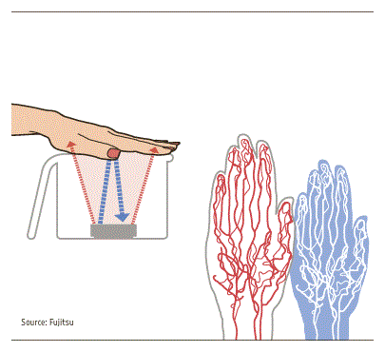

Retina Scan is very accurate. It works by converting the pattern of blood vessels and their intensity into a barcode. The retina is an internal layer which makes it suitable to be scanned because it is never misplaced, and it doesn’t catch dirt. Retinal scan results in precise information, it can never be wrong as well. Its chances of FAR (False Acceptance Rate) and FRR (False Recognition Rate) are almost 0%. Furthermore, there is never same retinas in two people and it can never be replicated, which makes it very secure. However, Retina Scan can take a bit of a long time for the IR to scan the pattern of the vessels, nevertheless, longer time can be an advantage as it will make it impossible to be hacked, that’s why I recommend it especially for very classified and important areas.
Figure 4 Shows Palm Vein Technology Mechanism
Figure 3 Shows the Blood Vessel in The Retina
Palm Vein technology is unique and highly accurate. Its FAR and FRR are very low, yet not lower than the retinal system. It is quite fast and comfortable, and on top of that, it is extremely secure and has no health issues. Veins have a long-term stability which makes this technology reliable. Additionally, it can never be copied or duplicated as it is inside the body.

INTERNET

The Internet is a worldwide system of computer networks which allows users with computers at any place around the world to exchange the information with each other.
Sometimes it simply abbreviated as The Net.
It was developed by the Advanced Research Projects Agency (ARPA) of the U.S. government in 1969 and was first known as the ARPAnet (Rouse, 2017).

NETIQUETTE:
Netiquette or net etiquette, also refers to as etiquette on the Internet.
Good netiquette generally means respecting the privacy of others on the internet and to not do something that will discomfort or trouble other people online.
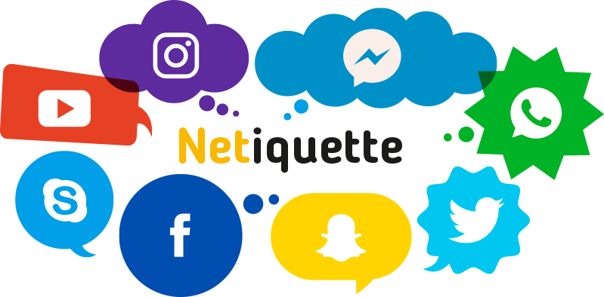
Most commonly good netiquettes are necessary in three areas e-mail, online chat, and newsgroups.
Therefore, by considering a few ordinary rules one can achieve a good online experience.
Rules of netiquette:
- Don't spam

Always keep in mind that spam is unsolicited electronic messages or
sending the same electronic message repeatedly. It can put you in troubles.

Some sites have strict rules regarding the spams and kind of ads, and simply it also irritates everyone else.

- Don’t plagiarize

Plagiarism is the act of using someone else’s words or ideas as your own. Creating your own content, gaining knowledge and paraphrasing or summarizing the part in your own words are some suitable ways to avoid plagiarism.

- Don’t overuse emoticons (emojis)

Emoticons are very useful in giving expressions and gestures to the conversation and in making the conversation interesting. But many times, overusing these cute looking emojis irritates or sometimes may offends the reader and it may also leads to misinterpretation of the message.

To Sum Up, by following some simple netiquettes can keep your internet connections happy and maintain relationships. Just like the real world, online users also prefer communicating with someone who has good etiquettes.

WEBSITE:
A group of interlinked Web pages sharing a single domain name that is accessible for every internet user is known as a website.
Sometimes it simply abbreviated as The Site.
It can be created and maintained by an Organisation or by an Individual. Together, all websites comes under the World Wide Web.
30 years back there was no website, but now the internet is so big that there are over 1.8 Billion websites today (Netcraft, 2018).
The first web page was created on august 6, 1991. The first website was: http://info.cern.ch/hypertext/WWW/TheProject.html (Shontell, 2011)

Google is a search engine website founded back in 1997 by Larry Page and Sergey Brin while they were studying Ph.D. at Stanford University, California. Before google, the two founders were collaborating on a project called “BackRub” that investigated about the linking of sites and webpages. (Kettler, 2014)
After sometimes, they both agreed to change its name and officially registered the domain as google.com.
In 2001, google started using an algorithm known as PageRank. Pagerank ranks the websites by following some criteria and shows the best results on top.
Google has more than 80% shares in terms of search engine and yahoo! is the closest rival of google (Heitzman, 2017). Google gets more than 3.5 Billion searches daily (Mangles, 2018), and by google ads the company is making good money. Today, Google has a net worth of $132 Billion (Forbes, 2018) and also has its own place in Oxford English Dictionary as a verb.
Some examples of websites under google:
YouTube- YouTube allows users to upload videos and music to share it with other people online.
Google Maps- Google maps help users to get driving directions and view maps. it has several features such as satellite imagery, Real-Time traffic, street maps, Street View perspectives and lot more.
Google Translate- Supporting more than 90 languages, Google translate translates the text, phrases and webpages instantly from one language to other.

Purpose of the Website:
Google’s corporate mission is “To organize the world’s information and make it universally accessible and useful.” (Thompson, 2018)
Depending on the interest of people, there are endless varieties of Websites, such as educational sites, news sites, forums, social media sites, e-commerce sites, and many more.
The main purpose of Search Engine Websites is to collect the relevant information which is present on the web or on the other websites, organize it and make it accessible and beneficial to users in order to make them learn something new or understands the things better.
Search engine helps in locating the information in variety of areas like news, health, entertainment, education etc.
Google is helpful in telling, what’s going on around the world by giving updates and news all the time. They are also helpful in finding disease by searching the symptoms and recommending the medicines also.
By reducing the time taken to locate the information and by making the information more accessible, the search engines are making people efficient.
Additionally, Google is also used as an advertisement site where big companies promote their business, both locally and internationally. Most of the companies creates an advertisement. Whenever the user search something related to their company or product, the ad appears on the top of the results.
To sum up, search engine websites such as Google.com can be used to gain information and marketing purposes.

WEB BROWSER:
To access a website or to view it, we use an application called web browser. Web browser processes the code used to make the webpages and place it in the browsing window for user to access the website.
Nowadays, numerous web browsers are there in the market, made accordingly, to serve the different compatibility needs and to run on different operating systems.

Google is a site that requires a good internet connectivity and a good browser for the best browsing experience. Some of the key feature that tells us about the browsers are:
- Privacy and Security
- Speed
- Good Features
Table below shows the comparison between two famous browsers, Google Chrome and Internet Explorer.

COMPARISON TABLE

GOOGLE CHROME | INTERNET EXPLORER
Chrome browser generally use google.com for default searches. | It generally use bing.com as the default search engine.
Consuming less RAM, chrome can run many tabs and is very fast for switching between tabs. | It also consumes less RAM, but very slow for switching between tabs.
It has many features and is very easy to use. | Comparatively, it has very less features  and difficult to use.
It is termed as the most secured browser. | Have already faced some serious security issues in past and is not secured.
Has a marketplace to buy and sell extensions. | Has no such support.
Is available for almost every device like Android, Linux, Windows, IOS and also on MacOS systems. | Is limited to Desktops only.

Recommended Browser: Google Chrome
As it is clear from the above table, Google Chrome is very convenient and user-friendly, and is better than any other browser in a number of ways such as, it is more secured to keep your device safe while browsing, it loads faster than any other browser, and the best part is that, it is compatible with many devices and operating systems. It can also sync user preferences from multiple devices. It also provides a help forum to interact with other users for help and support and for giving feedbacks.
For the default searches, the chrome browser is using google search engine, making the searches easy, quick and more relevant to what the user seeking. Hence, Google Chrome is more suitable web browser for users as compared to any browser.

Compare & Contrast

In this 21st century, the cloud computing trend is rising in demand. Google introduced Google Cloud Platform (GCP) in 2008 meanwhile Amazon presented Amazon Web Service (AWS) in 2006. In this assignment, we’ll compare and contrast both companies below.

Compute
Google Compute Engine and Amazon Web Service EC2 is used by Google and Amazon to handle virtual machines. Both company offered a variety of specific amounts of virtual CPU, RAM and network. Google Compute Engine refers to them as machine types, whereas Amazon EC2 refers to them as instance types. Amazon enable its users to equip AWS EC2 up to 128 vCPUs and 3904 GB of RAM while Google enable its users to equip Google Compute Engine up to 96 vCPUs and 624 GB of RAM. Thus, Google Cloud Platform enable users to customize the amount of CPUs and RAM to use.
(Anon., 2018) (Korkishko, 2018)

Billing & Pricing
Google Cloud Platform has slightly cheaper in its compute and storage costs compare to Amazon Web Service. For example, Amazon Web Service (AWS) offered 2 CPUs per 8GB RAM instance will cost 69 dollars per month meanwhile Google Cloud Platform only costs 52 dollars per month which is 25% cheaper than Amazon Web Service (AWS). In addition, Google Cloud Platform offered a multi-regional cloud storage option that the user has to pay a little cost with 2.6 cents per GB per month to replicate their data automatically across several regions. On the other hand, the billing model of Amazon Web Service (AWS) and Google Cloud Platform pay per hour and pay per minutes respectively. However, these two companies announced the new pay per second billing model. Furthermore, Google Cloud Platform provide a long-term usage discount. Google Cloud Platform will automatically provide the discounts to appreciate its loyal customers with no reservation required whereas Amazon Web Service (AWS) required user to reserve instances for long period of time. Moreover, Google Cloud Platform introduced a committed-use discount up to 57% meanwhile the customers can enjoy a total amount of CPUs and RAM per month, regardless the instance configuration and region.
(Aboukhalil, 2018)

Security
Amazon Web Service (AWS) provide cloud security to its customers and maintain them in a secure environment. Amazon Cognito is product sign in and sign up that allowed user to sign up/sign in and access control to user’s web and mobile apps quickly and easily. Amazon Macie is a sensitive data classification that machine learning-powered security service to discover, classify and protect sensitive data. AWS Organizations is a multiple account management that offered policy-based management for multiple AWS accounts.
Google Cloud Platform offered security products that help users meet policy, regulatory and business objectives. The controls and capability Google Cloud Platform offer is expanding time by time. Infrastructure security is known as rely on a secure-by-design infrastructure with hardening, configuration management, patch and vulnerability management. Thus, network security is help secure the network with products that define and enforce user perimeter, and allow for network segmentation, remote access, and DoS defence. Moreover, data security is make sensitive data more secure with data discovery, controls to prevent loss and data governance. Security monitoring and operations monitor for malicious activity, handle security incidents, and support operational processes that prevent, detect and respond to threats. In addition, governance, risk and compliance is to support governance and compliance processes, including performing assessments, demonstrating compliance, and achieving certifications.
(Google Security Overview, 2018) (Google Cloud, 2018) (AWS Cloud Security, n.d.) (AWS, 2018)

Conclusion

The various aspects about Green computing, Carpel Tunnel Syndrome, Security, Internet, and Video Conference are summarized below.
In Green computing part, we found that Google has been leading the world in Green computing for certain reasons. Since 2007, Google has been trying to reduce energy use, including renewable energy and offsetting carbon emissions to achieve green computing plan. Google is investing in green schemes to reduce conventional energy use and use renewable energy to offset emissions. Google is trying to solve the problem from the root of the problem.
Secondly, we learned the causes, consequences and preventive measures of Carpel Tunnel Syndrome. Carpel Tunnel Syndrome will affect not only our work but also our health. Many organizations are aware of the harm caused by this problem and are reducing the probability of the disease. As an IT student, this lesson is necessary before joining the workplace.
Besides, the video conference facilitates both organizations and individuals via the Internet. It will more than save costs, improve productivity, another benefit is to help the environment by reducing the carbon footprint.
Furthermore, we learned the differences and preventive measures between Trojans, worms, and viruses. In this Internet era, a no security knowledge society is just like opening the door of the bank vault. However, understanding cracker and learning how to prevent intrusion is a compulsory course.
At last, the Internet has become an essential tool for human communication in today's society. However, we never thought about what is chat etiquette while we use the Internet to chat every day. There are rules that we followed but we aren’t aware of. Hope everyone can use the Internet in a civilized way.

Reference
Aboukhalil, R., 2018. A Tale of Two Clouds: Amazon vs. Google. [Online]
Available at: https://medium.com/@robaboukhalil/a-tale-of-two-clouds-amazon-vs-google-4f2520516a38
[Accessed 1 December 2018].
Anon., 2018. Compute Products. [Online]
Available at: https://cloud.google.com/compute/docs/disks/performance
[Accessed 1 December 2018].
Anon., n.d. Cloud Storage with AWS. [Online]
Available at: https://aws.amazon.com/products/storage/
Anon., n.d. Networking Products. [Online]
Available at: https://cloud.google.com/network-tiers/
Anon., n.d. Networking Products with AWS. [Online]
Available at: https://aws.amazon.com/products/networking/
Anon., n.d. Storage Options. [Online]
Available at: https://cloud.google.com/compute/docs/disks/
Anon., n.d. Storage Products. [Online]
Available at: https://cloud.google.com/storage/features/
Anon, 2018. G Suite Pricing, Features, Reviews & Comparison of Alternatives. [Online]
Available at: https://www.getapp.com/collaboration-software/a/google-apps-for-business/
[Accessed 20 October 2018].
AWS Cloud Security, n.d. The Beginner's Guide to Cloud Security. [Online]
Available at: https://aws.amazon.com/security/introduction-to-cloud-security/
[Accessed 1 December 2018].
AWS, 2018. Cloud Security, Identity & Compliance with AWS. [Online]
Available at: https://aws.amazon.com/products/security/
[Accessed 1 December 2018].
Bethesda, 2018. Carpal Tunnel Syndrome Fact Sheet. [Online]
Available at: https://www.ninds.nih.gov/Disorders/Patient-Caregiver-Education/Fact-Sheets/Carpal-Tunnel-Syndrome-Fact-Sheet
Charles D. Jennings, M., 2016. Carpal Tunnel Syndrome. [Online]
Available at: https://orthoinfo.aaos.org/en/diseases--conditions/carpal-tunnel-syndrome/
Claussen, L., 2011. Workplace myth?. [Online]
Available at: https://www.safetyandhealthmagazine.com/articles/6383-workplace-myth
Google Cloud, 2018. Products & Capabilities. [Online]
Available at: https://cloud.google.com/security/products/
[Accessed 2018 December 2018].
Google Security Overview, 2018. Google Security Overview. [Online]
Available at: https://cloud.google.com/security/overview/
[Accessed 1 December 2018].
Gordon, K., 2018. Google - Statistics & Facts. [Online]
Available at: https://www.statista.com/topics/1001/google/
[Accessed 19 11 2018].
Grosteffon, K., 2012. Two Things to Consider when Using a Mouse Pad/Wrist Rest. [Online]
Available at: https://www.humantech.com/two-things-to-consider-when-using-a-mouse-padwrist-rest/
Guay, M., 2017. The 12 Best Video Conferencing Apps for Teams. [Online]
Available at: https://zapier.com/blog/best-video-conferencing-apps/
[Accessed 22 October 2018].
Guay, M., 2018. The Google Chat Guide: Everything You Need to Know About Google Hangouts Meet, Chat, and More. [Online]
Available at: https://zapier.com/blog/google-hangouts-meet-guide/
[Accessed 22 October 2018].
Heitzman, A., 2017. How Google Came To Dominate Search And What The Future Holds. [Online]
Available at: https://www.forbes.com/sites/forbesagencycouncil/2017/06/05/how-google-came-to-dominate-search-and-what-the-future-holds/#79f805183872
[Accessed 19 10 2018].
INVICTUS, S., 2018. GOOGLE USES WIND AND SOLAR TO OFFSET IT’S CARBON FOOTPRINT. [Online]
Available at: http://www.getsolarize.com/google-creates-zero-carbon-footprint/
[Accessed 1 November 2018].
INVICTUS, S., 2018. GOOGLE USES WIND AND SOLAR TO OFFSET IT’S CARBON FOOTPRINT. [Online]
Available at: http://www.getsolarize.com/google-creates-zero-carbon-footprint/
[Accessed 1 November 2018].
IVCI, W. i. V. C. |. B. o. U. C. S. -., 2017. What is Video Conferencing? | Benefits of Using Conferencing Solutions - IVCI. [Online]
Available at: https://ivci.com/collaboration/what-is-video-conferencing/
[Accessed 22 October 2018].
Janice, 2017. What Is Video Conferencing?-Definition and How It Works | ezTalks. [Online]
Available at: https://www.eztalks.com/video-conference/what-is-video-conferencing.html
[Accessed 22 October 2018].
Jones, B., 2018. Skype for Business Pricing, Features, Reviews & Comparison of Alternatives. [Online]
Available at: https://www.getapp.com/it-communications-software/a/skype-for-business/
[Accessed 22 October 2018].
Kettler, S., 2014. The Google Chronicles: 7 Facts on Founders Larry Page & Sergey Brin. [Online]
Available at: https://www.biography.com/news/google-founders-history-facts
[Accessed 18 10 2018].
Korkishko, I., 2018. AWS vs Google Cloud Platform. What is better for DevOps in the cloud?. [Online]
Available at: https://medium.com/@Iren.Korkishko/aws-vs-google-cloud-platform-what-is-better-for-devops-in-the-cloud-434a7cefa25a
[Accessed 1 December 2018].
Mangles, C., 2018. Search Engine Statistics 2018. [Online]
Available at: https://www.smartinsights.com/search-engine-marketing/search-engine-statistics/
[Accessed 19 10 2018].
MCGRATH, J., 2011. Google’s Green Initiative: Environmentally Conscious Technology. [Online]
Available at: https://www.technobuffalo.com/2011/05/18/googles-green-initiative-environmentally-conscious-technology/
[Accessed 29 October 2018].
Nordqvist, C., 2018. Carpal tunnel syndrome: What you need to know. [Online]
Available at: https://www.medicalnewstoday.com/articles/184337.php
Rashid, F. Y., 2017. Microsoft Skype for Business. [Online]
Available at: https://sea.pcmag.com/internet-telephony-voip-products/4222/microsoft-skype-for-business
[Accessed 22 October 2018].
Rouse, M., 2016. What is video conference (video conferencing)? - Definition from WhatIs.com. [Online]
Available at: https://searchunifiedcommunications.techtarget.com/definition/video-conference
[Accessed 16 October 2018].
Rouse, M., 2017. ARPANET. [Online]
Available at: https://searchnetworking.techtarget.com/definition/ARPANET
[Accessed 15 11 2018].
Shinder, D., 2008. 10 tips for implementing green IT. [Online]
Available at: https://www.techrepublic.com/blog/10-things/10-tips-for-implementing-green-it/
[Accessed 20 October 2018].
Shontell, A., 2011. FLASHBACK: This Is What The First-Ever Website Looked Like. [Online]
Available at: https://www.businessinsider.com/flashback-this-is-what-the-first-website-ever-looked-like-2011-6/?IR=T
[Accessed 15 11 2018].
Solution, H., 2017. Top 5 Reasons to Use an Ergonomic Mouse. [Online]
Available at: https://www.thehumansolution.com/blog/top-5-reasons-to-use-an-ergonomic-mouse/
Staff, M. C., 2017. Carpal Tunnel Syndrome. [Online]
Available at: https://www.mayoclinic.org/diseases-conditions/carpal-tunnel-syndrome/diagnosis-treatment/drc-20355608
Sullivan, D., 2016. Google now handles at least 2 trillion searches per year. [Online]
Available at: https://searchengineland.com/google-now-handles-2-999-trillion-searches-per-year-250247
[Accessed 19 11 2018].
Thompson, A., 2018. Google’s Mission Statement and Vision Statement (An Analysis). [Online]
Available at: http://panmore.com/google-vision-statement-mission-statement
[Accessed 22 10 2018].
WebWise Team, 2012. BBC - WebWise - What is netiquette?. [Online]
Available at: http://www.bbc.co.uk/webwise/guides/about-netiquette
[Accessed 17 10 2018].
Wheeland, M., 2007. Green Computing at Google. [Online]
Available at: https://www.greenbiz.com/news/2007/05/02/green-computing-google
[Accessed 25 September 2018].
Zych, D., 2013. The Importance of Ergonomics - Mice. [Online]
Available at: https://davidzych.com/the-importance-of-ergonomics-mice/
What is a Trojan? Is it virus or malware? How it works. 2018. What is a Trojan? Is it virus or malware? How it works. [ONLINE] Available at: https://us.norton.com/internetsecurity-malware-what-is-a-trojan.html. [Accessed 26 October 2018].
Cisco. 2018. What Is the Difference: Viruses, Worms, Trojans, and Bots? - Cisco. [ONLINE] Available at: https://www.cisco.com/c/en/us/about/security-center/virus-differences.html. [Accessed 26 October 2018].
Kaspersky.2018.What are Trojans? [ONLINE] Available at: https://usa.kaspersky.com/resource-center/threats/trojans. [Accessed 26 October 2018].
HowStuffWorks. 2018. Protecting Yourself from Trojan Horses | HowStuffWorks. [ONLINE] Available at: https://computer.howstuffworks.com/trojan-horse1.htm. [Accessed 26 October 2018].
SearchSecurity. 2018. What is Trojan horse (computing)? - Definition from WhatIs.com. [ONLINE] Available at: https://searchsecurity.techtarget.com/definition/Trojan-horse. [Accessed 26 October 2018].
#irchelp. 2018. IRCHelp.org — Trojan Horses. [ONLINE] Available at: http://www.irchelp.org/security/trojan.html. [Accessed 26 October 2018].
Trojan Virus. 2018. Trojan Virus. [ONLINE] Available at: http://www.tech-faq.com/trojan-virus.html. [Accessed 26 October 2018].
Redshift EN. 2018. Infected! 10 Tips How To Prevent Malware On Your Computer. [ONLINE] Available at: https://www.autodesk.com/redshift/10-tips-on-how-to-prevent-malware-from-infecting-your-computer/. [Accessed 26 October 2018].
levinec. 2018. Prevent malware infection | Microsoft Docs. [ONLINE] Available at: https://docs.microsoft.com/en-us/windows/security/threat-protection/intelligence/prevent-malware-infection. [Accessed 26 October 2018].
CA Veracode. 2018. Malware Types, Information and Prevention Strategy | CA Veracode. [ONLINE] Available at: https://www.veracode.com/security/malware. [Accessed 26 October 2018].
TechRepublic. 2018. 10 ways to avoid viruses and spyware - TechRepublic. [ONLINE] Available at: https://www.techrepublic.com/blog/10-things/10-ways-to-avoid-viruses-and-spyware/. [Accessed 26 October 2018].
Kaspersky.2018.What is malware and how to protect against it? [ONLINE] Available at: https://www.kaspersky.com/resource-center/preemptive-safety/what-is-malware-and-how-to-protect-against-it. [Accessed 26 October 2018].
PCWorld. 2018. How to Avoid Malware | PCWorld. [ONLINE] Available at: https://www.pcworld.com/article/210891/malware.html. [Accessed 26 October 2018]
Swift Systems. 2018. 3 Tips - How to Prevent Malware | Swift Systems. [ONLINE] Available at: https://swiftsystems.com/3-malware-prevention-tips/. [Accessed 26 October 2018].
How to secure your webcam and help prevent webcam hacking. 2018. How to secure your webcam and help prevent webcam hacking. [ONLINE] Available at: https://us.norton.com/internetsecurity-malware-webcam-hacking.html. [Accessed 26 October 2018].
Types of Biometrics · About Biometrics · Biometrics. 2018. Types of Biometrics · About Biometrics · Biometrics. [ONLINE] Available at: https://www.biometricsinstitute.org/types-of-biometrics. [Accessed 26 October 2018].
Biometric authentication: what method works best?. 2018. Biometric authentication: what method works best?. [ONLINE] Available at: http://www.technovelgy.com/ct/Technology-Article.asp?ArtNum=16. [Accessed 26 October 2018].
Bayometric. 2018. Compare Fingerprint Recognition and Palm Vein Technology. [ONLINE] Available at: https://www.bayometric.com/compare-fingerprint-recognition-and-palm-vein-technology/. [Accessed 26 October 2018].
Bayometric. 2018. False Acceptance Rate and False Recognition Rate. [ONLINE] Available at: https://www.bayometric.com/false-acceptance-rate-far-false-recognition-rate-frr/. [Accessed 26 October 2018].
WhatIs.com. 2018. What is palm vein recognition? - Definition from WhatIs.com. [ONLINE] Available at: https://whatis.techtarget.com/definition/palm-vein-recognition. [Accessed 26 October 2018].
Retinography - used, blood, body, uses, device, How Retinal Scanning Works, Applications, Advantages and Disadvantages. 2018. Retinography - used, blood, body, uses, device, How Retinal Scanning Works, Applications, Advantages and Disadvantages. [ONLINE] Available at: http://www.discoveriesinmedicine.com/Ra-Thy/Retinography.html. [Accessed 26 October 2018].
Iris recognition vs retina scanning. 2018. Iris recognition vs retina scanning. [ONLINE] Available at: https://www.bytechplanet.com/blog/iris-recognition-vs-retina-scanning/. [Accessed 26 October 2018].
BiometricUpdate. 2018. Explainer: Retinal Scan Technology | BiometricUpdate. [ONLINE] Available at: https://www.biometricupdate.com/201307/explainer-retinal-scan-technology. [Accessed 26 October 2018].
M2SYS Blog On Biometric Technology. 2018. Iris Recognition vs. Retina Scanning - What are the Differences? - M2SYS Blog On Biometric Technology. [ONLINE] Available at: http://www.m2sys.com/blog/biometric-hardware/iris-recognition-vs-retina-scanning-what-are-the-differences/. [Accessed 06 December 2018].
IT PRO. 2018. The 10 best (or should that be worst?) malware attacks | IT PRO. [ONLINE] Available at: https://www.itpro.co.uk/security/innovation-at-work/29577/the-10-best-or-should-that-be-worst-malware-attacks. [Accessed 06 December 2018].
The Drum. 2018. Google purges 20 Trojan Horse Play Store apps for spying on users | The Drum. [ONLINE] Available at: https://www.thedrum.com/news/2017/07/29/google-purges-20-trojan-horse-play-store-apps-spying-users. [Accessed 06 December 2018].
Elinor Mills. 2018. Behind the China attacks on Google (FAQ) - CNET. [ONLINE] Available at: https://www.cnet.com/news/behind-the-china-attacks-on-google-faq/. [Accessed 06 December 2018].
WIRED. 2018. Google Hack Attack Was Ultra Sophisticated, New Details Show | WIRED. [ONLINE] Available at: https://www.wired.com/2010/01/operation-aurora/. [Accessed 06 December 2018].
Mydoom - The Virus Encyclopedia. 2018. Mydoom - The Virus Encyclopedia. [ONLINE] Available at: http://virus.wikidot.com/mydoom. [Accessed 06 December 2018].
Joe Stewart. 2018. Operation Aurora: Clues in the Code | Secureworks. [ONLINE] Available at: https://www.secureworks.com/blog/research-20913. [Accessed 06 December 2018].
Computer Trojan Horse Virus Information . 2018. Computer Trojan Horse Virus Information . [ONLINE] Available at: https://www.bullguard.com/bullguard-security-center/pc-security/computer-threats/what-is-a-trojan-horse. [Accessed 06 December 2018].
How we started and where we are today | Google. 2018. How we started and where we are today | Google. [ONLINE] Available at: https://www.google.com/about/our-story/. [Accessed 06 December 2018].
Small Business. 2018. A Brief History of Google. [ONLINE] Available at: https://smallbusiness.yahoo.com/advisor/brief-history-google-192150025.html. [Accessed 06 December 2018].
Statista. 2018. • Number of Google employees 2017 | Statista. [ONLINE] Available at: https://www.statista.com/statistics/273744/number-of-full-time-google-employees/. [Accessed 06 December 2018].
Paul R. La Monica. 2018. Amazon tops Google as second most valuable company in US . [ONLINE] Available at: https://money.cnn.com/2018/03/20/investing/amazon-google-alphabet-market-value/index.html. [Accessed 06 December 2018].

Weekly Task report
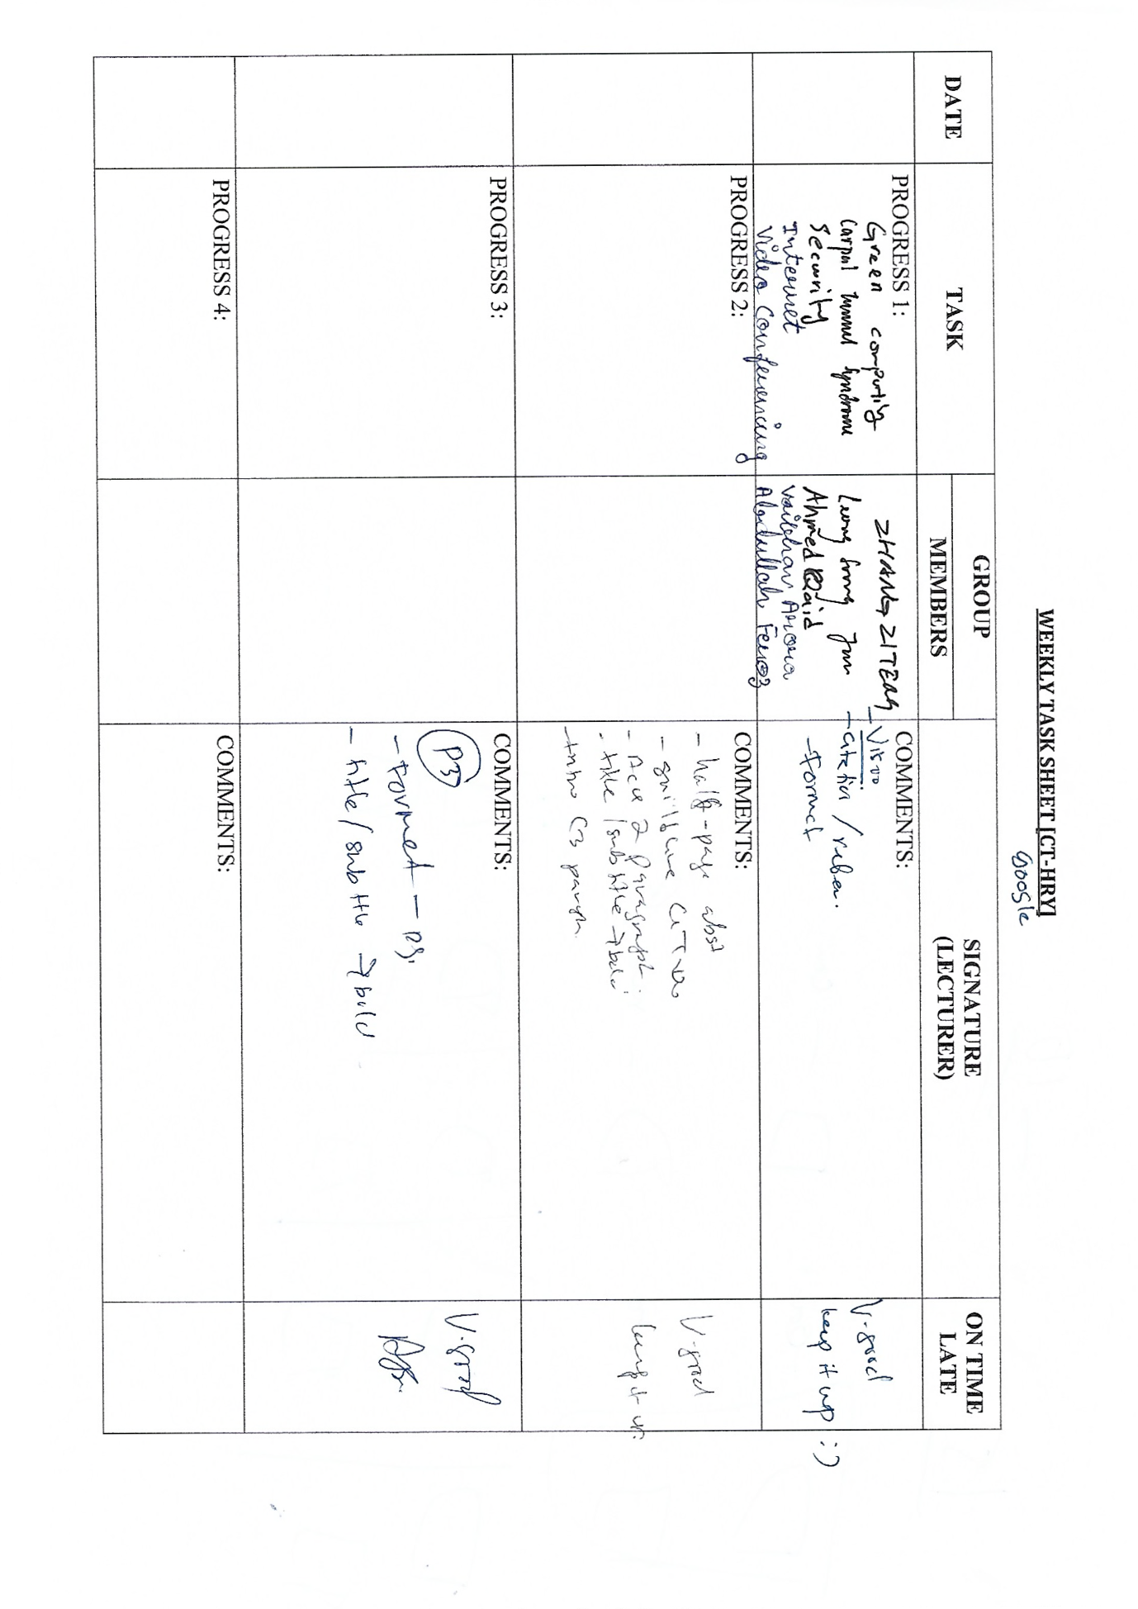

Work Breakdown Structure (WBS)

No. | Date | Name | Task / Description / Responsibility | Signature
1. |  | Zhang Ziteng | Green Computing & Conclusion
2. |  | Leong Soongjun | Carpal Tunnel Syndrome & Compare and Contrast
3. |  | Abdullah Feroz Ansari | Video Conferencing &Abstract and Acknowledgement
4. |  | Ahmed Qaid | Security & Introduction
5. |  | Vaibhav Arora | Internet & Reason Choosing

